Standards At A Glance

SOL: 5.1 The student will, given a decimal through thousandths, will round to the nearest whole number, tenth, or hundredth.

Student – Friendly Objective:
- I will be able to round decimals in a way that is similar to the way whole numbers are rounded.
- I will round decimals to the nearest whole number, tenth and hundredth.
- I will round decimals to estimate when an exact number is not needed for the situation at hand.

Vocabulary: decimal number, decimal point, digit, expanded form, place value, round

Parameters:
- Decimal numbers given will be written through the thousandths.
- Decimals will be rounded to the nearest whole number, tenth, or hundredth.

What it looks like….

1 Click on each box to choose a number. You must select all of the correct answers.
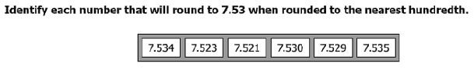

2 What is 36.357 rounded to the nearest tenth?
A 40.0
B 36.4
C 36.3
D 30.0

Standards At A Glance

SOL: 5.2 The student will:
a) recognize and name fractions in their equivalent decimal form and vice
versa; and
b) compare and order fractions and decimals in a given set from least to
greatest and greatest to least.

Student – Friendly Objective:
1. I will name fractions and their equal decimal form, or vice versa.
2. I will compare and order fractions from least to greatest, or greatest to least.
3. I will compare and order decimals from least to greatest or greatest to least.
4. I will compare and order fractions and decimals from least to greatest, or greatest to least.

Vocabulary: decimal, number, decimal point, place value, fraction, denominator, equivalent, numerator, greater than, less than, equal to, compare, order, symbol

Parameters:
- denominators will be 12 or less.
- represent fractions (halves, thirds, fourths, fifths, eighths, and twelfths) in equivalent decimal form and vice versa.
- comparing and ordering will have sets of no more than five fractions, decimals, or mixed numbers.
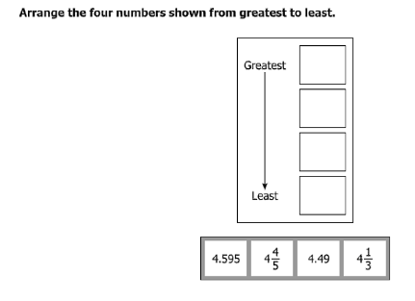
What it looks like….
1

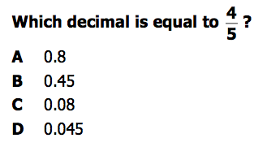
2

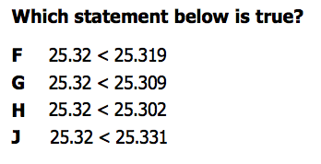
3

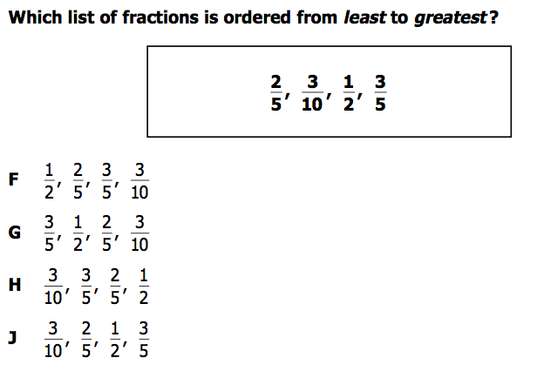
4

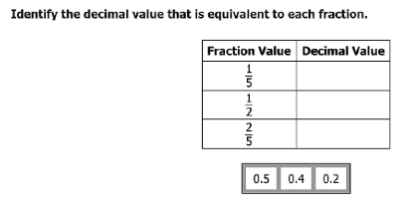
5

Standards At A Glance

SOL: 5.3 The student will:
a) identify and describe the characteristics of prime and composite numbers;
and
b) identify and describe the characteristics of even and odd numbers.

Student – Friendly Objective:
1. I will name all prime numbers up to 99.
2. I will be able to identify if a number is odd or even.

Vocabulary: prime, composite, odd, even, rectangular array, prime factorization, factor, divisible / divisibility
Parameters:
- Identify prime and composite numbers up to 100.
- One is neither prime nor composite; its only factor is itself.
- An odd number does not have 2 as a factor.
- Odd numbers have an odd number in the ones place.
- Even numbers have an even number, or zero, in the ones place.
- The sum/difference of two even numbers is even.
- The sum/difference of two odd numbers is even.
- The sum/difference of even and odd number is odd.
What it looks like….

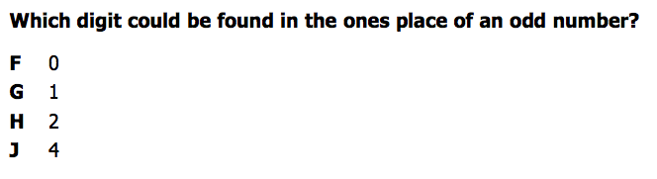
1

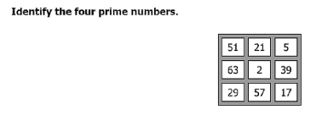
2

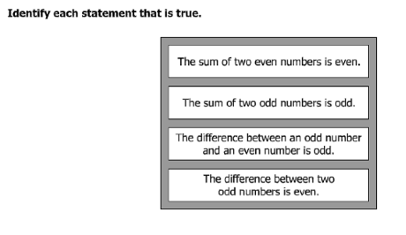
3

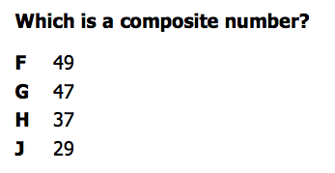
4

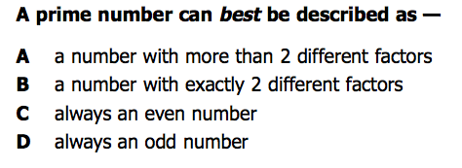
5

Standards At A Glance

SOL: 5.4 The student will create and solve single-step and multistep problems involving addition, subtraction, multiplication, and division with and without remainders of whole numbers.

Student – Friendly Objective:
- I will create and solve single-step problems with addition, subtraction, multiplication and division with and without remainders of whole numbers.
- I will create and solve multistep problems with addition, subtraction, multiplication, and division with and without remainders of whole numbers.

Vocabulary: sum, difference, product, quotient, divisor, dividend, factors

Parameters:
- Estimate the sum, difference, product, and quotient of whole number computations.
- Sums, differences, and products will not exceed five digits
- Multipliers will not exceed two digits
- Divisors will not exceed two digits
- Dividends will not exceed four digits
- Use two or more operational steps to solve a multistep problem
- When solving a multistep problem, operations can be the same or different.
What it looks like….
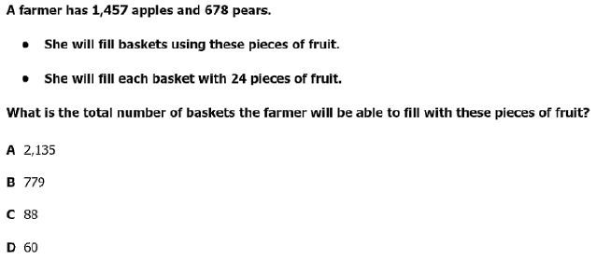
1

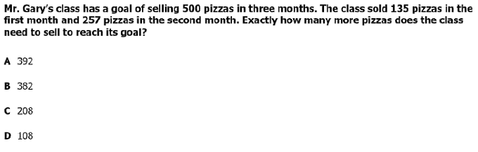
2

3
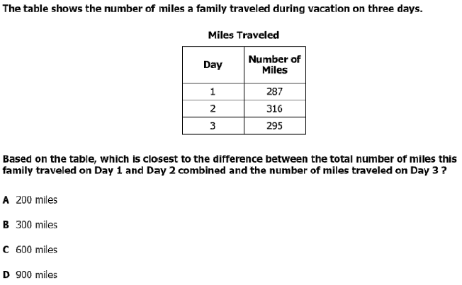

The Standards At A Glance

SOL: 5.15 The student, given a problem situation, will collect, organize, and interpret data in a variety of forms, using stem-and-leaf plots and line graphs.

Student – Friendly Objective:
1. I will be able to gather data.
2. I will be able to make a bar graph and line graph with data I collect or am given.
3. I will be able tell what a graph shows and write a sentence about it.

Vocabulary: stem-and-leaf plot, line graph, categories, axis, vertical, horizontal, data, continuous data, increments, scale, characteristics, observation, survey, experiment, minimum value, maximum value, variable

Parameters:
Line Graphs
- Data should be in equal increments of whole numbers, fractions, or decimals, depending upon the data being collected.
- Line graphs will have no more than 6 identified points along a continuum for continuous data. (Example: hours, days, months and age)
- Each axis should be labeled.
- The graph should be titled.
Stem-and-Leaf
- Stem is listed in ascending order.
- Leaves are in ascending order, with or without commas between leaves.
- The graph should be titled.

What it looks like….

1 Click and drag each selected number to the correct location. You may use each number more than one time.
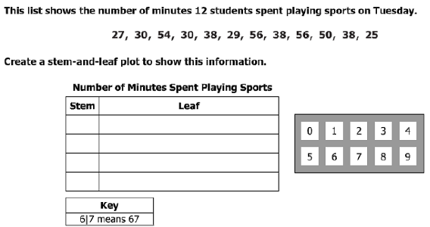

2
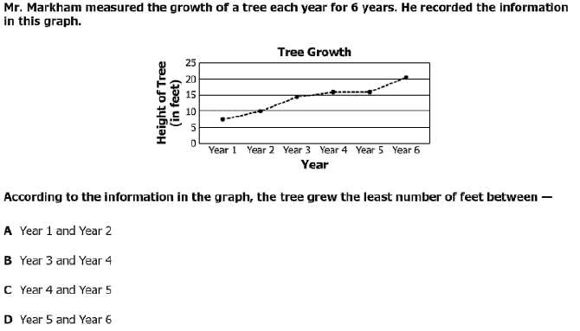

Standards At A Glance

SOL: 5.19 The student will investigate and recognize the distributive property of multiplication over
addition.

Student – Friendly Objective:
1. I will create a visual representation of the distributive property using arrays.
2. I will use the distributive property to simplify expressions.
3. I will pick equations that show the distributive property.

Vocabulary: sum, product, addend, add, multiply, simplify, expression, array

Parameters:
- create arrays to represent the expression.
- multiply each addend by a number and ADD the product.

What it looks like….

1 Which equation shows the use of distributive property?

2(5 + 3) = (2 x 5) + (2 x 3) (5 x 4) x 9 = 5 x (4 x 9)

(6 + 2) + 4 = 6 + (2 + 4) 3 x 5 x 7 = 7 x 3 x 5

7 + 6 + 1 = 6 + 7 + 1 (9 x 8) + (9 x 3) = 9(8 + 3)

2 Which equation shows the use of distributive property?

A 4 x 2 x 7 = 2 x 4 x 7

B 15(6 + 3) = 15 x 6 x 3
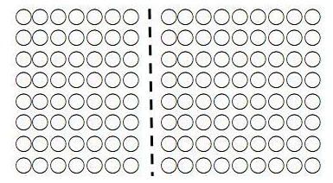
C 6 x (9 x 5) = (6 x 9) x 5

D 8(1 + 3) = (8 x 1) + (8 x 3)

3 Which equation best represents this array model of the distributive property?

A 10 x 7 = 11 x 8

B 8 x (10 x 9) = (8 x 10) x 9

C (8 x 7) + (8 x 9) = 8(7 + 9)

D 7 x 9 x 8 = 8 x 7 x 9

